# **Flight Management System**

# **(Using SpringBoot-Backend):**

## **Abstract**

The Flight Management System is a Java-based booking solution for flight tickets. It consolidates data provided by different airline carriers and hence provides the user details and rates in real-time. Travelers may want to make changes in their bookings. The application allows them to book, cancel, view, and update their bookings with ease. Other than this, it eases the management of bookings too. All the bookings, flights, schedules, and routes can be viewed, added, and modified on a single application by the administrator.

## **Scope**

### **Inscope:**

Following is the functionality provided by the system:   
There are two categories of people who would access the system: customer and administrator.  
Each of these would have some exclusive privileges.

#### **The customer can:**

* Create his user account.
* Login into the application.
* Check for available flights.
* Make a booking.
* View the bookings made.
* Cancel or modify a booking.

#### **The administrator can:**

* Login into the application.
* Add flight, schedule and route details.
* View the flight, schedule and route details.
* Cancel or modify the flight, schedule and route details.

### **Outscope:**

The following functionalities have not been covered under the application:

* The application does not cover boarding pass generation and seating plans.
* Payments are not yet accepted by the application.

### **Database Design:**

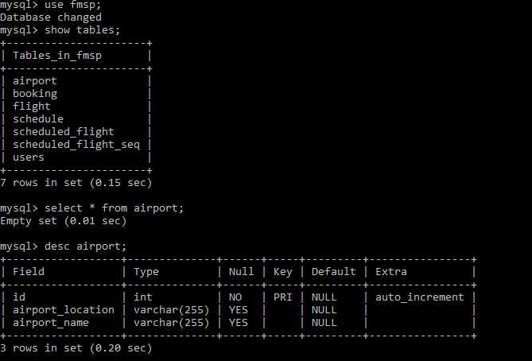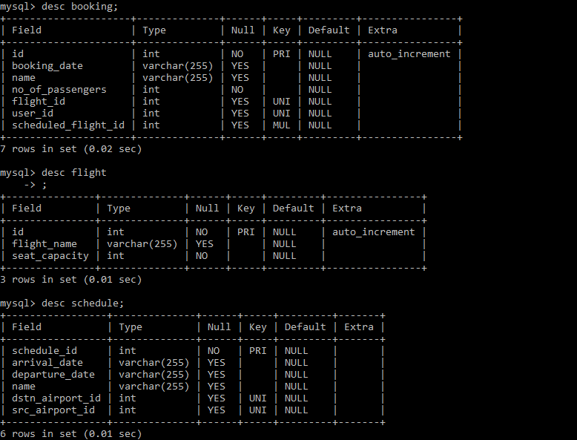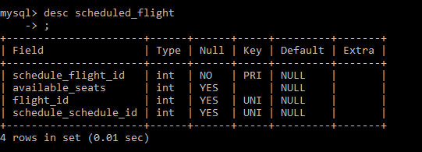

### **ER Diagram:**

